NEWS LETTER
Southern Tier of New York Chapter November 2018

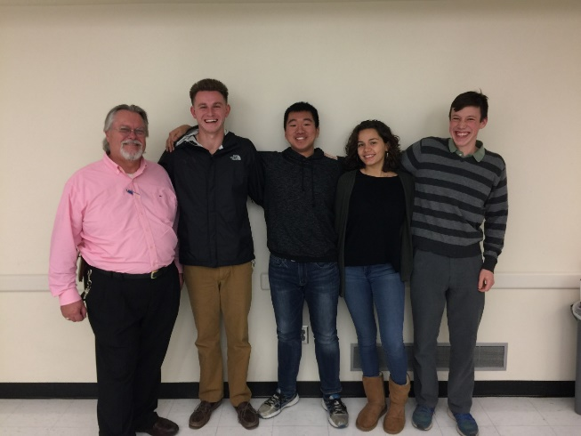
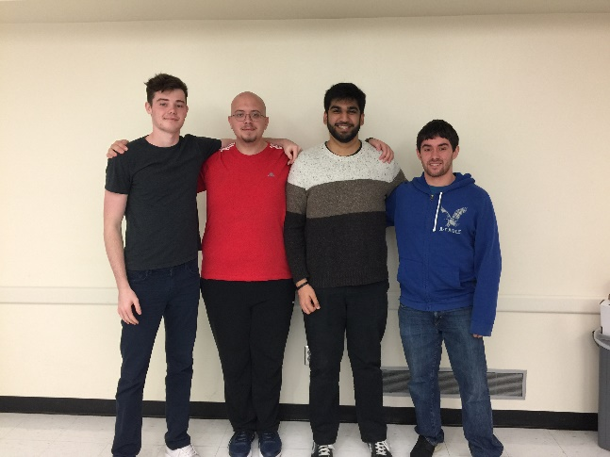
APICS Student Case Competition sends two more teams to Chicago competition representing Binghamton University. Team eliminations happened at the end of October at Binghamton University and the two winning teams recorded their solution and sent their recordings to APICS Corporate headquarters in Chicago recently and will represent the college for round one of the APICS Corporate Student Case Competition. The two teams are ready and excited to be competing against schools all over the world. Team one (pictured left) is lead by Satvik Sethi. Team two is lead by team leader Wei Xiang Chen.
L-R Gary Robbins, Kutay Karaca, Satvik Sethi (team leader), Alexander Robbins
Don Sheldon, Professor of Supply Chain Problem Solving, the class where the teams prepare said, “The students worked hard and put together good solutions for the case.”
Deloitte Consulting will be judging the competition in Chicago. We wish the teams all the best!
L-R Don Sheldon (coach), Kyle Balmer, Wei Xiang Chen (team leader), Carman Guzman, Isaiah Evans

Page 1 of 2
Student and Professional Chapters hold joint Operations Tour
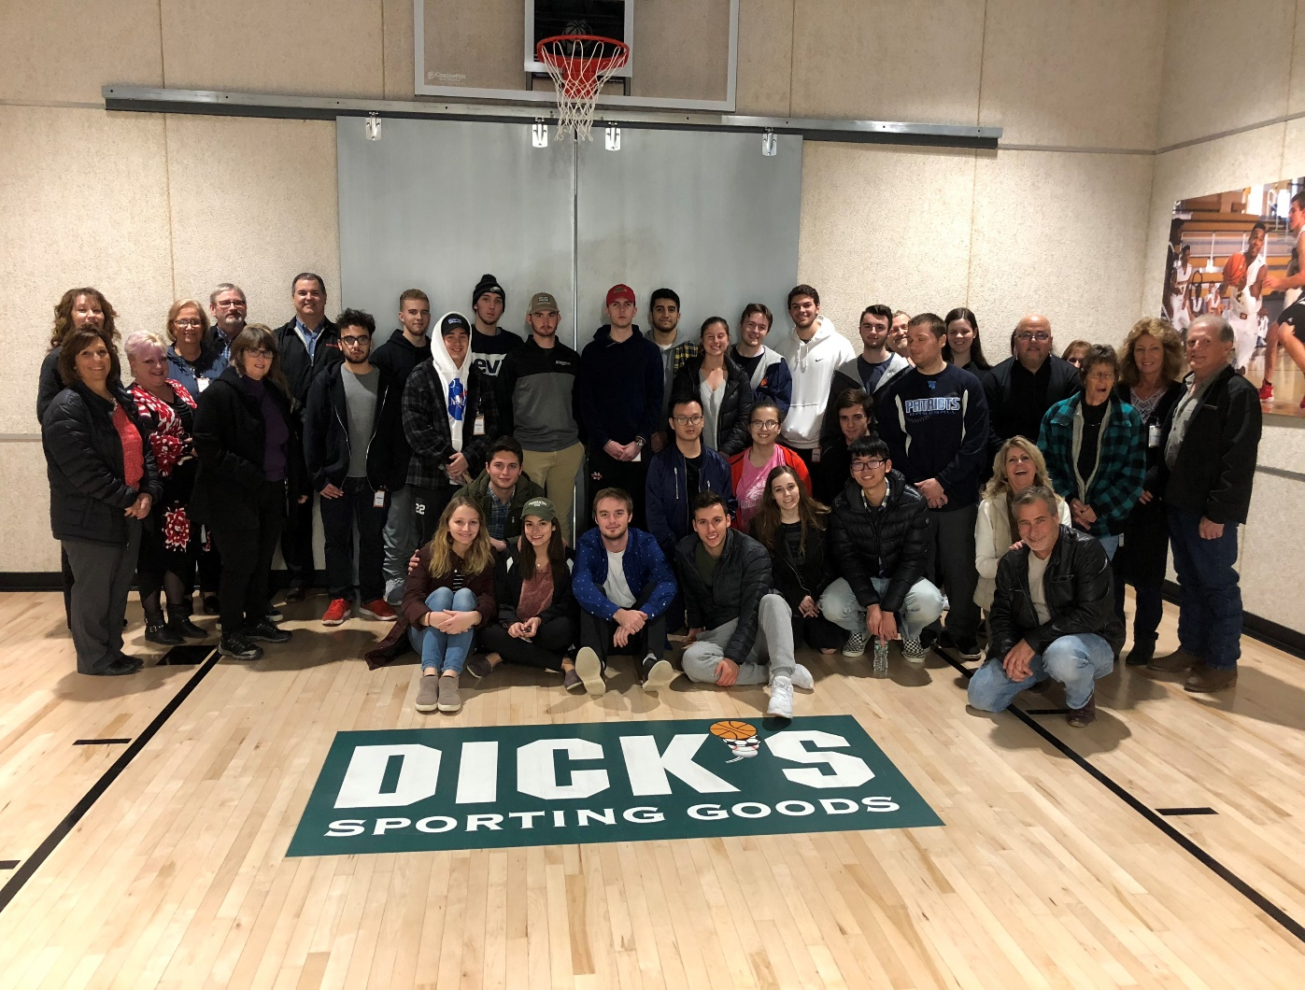
On November 1st, Dick’s Sporting Goods, under the hospitality of Steve Whited, both Manager at the Distribution Center and also a local Board of Director member of the Southern Tier Chapter of APICS provided an extensive and interesting tour of their massive distribution center in Conklin, NY. The tour walked through the huge warehouse facility, seeing the vast number of receiving and shipping docks, miles of conveyor belts, large variety of products in their inventory. The group was shown how Dick’s manages the retail store replenishment process. People new to the Broome County area learned that Dick’s got its start right here in Binghamton! Students and professionals alike were interested and amazed to see this brand-new facility. THANK YOU, Dick’s and especially Steve Whited for hosting this great event.
Steve Whited, Dick’s manager
Steve Stanchak, Local APICS President

Presidents message : Steve Stanchak

APICS in the Southern Tier
Recently I wrote all the chapter members an individual note and now it’s time to appeal to a larger group. Writing the notes was not a huge burden because the chapter is down to 16 members. Not a good situation. I know this news letter goes out to many others interested in the supply chain field but not APICS members .. we desperately need you to get involved!!
Membership is close to an all time low. Our BOD is … well long in the tooth with some serving for decades. We need new blood, new ideas and new commitment. If you are in any of the supply chain fields in the area … APICS is the organization that represents you !!
Invest in your career. APICS and the local chapter can help you. Get certified.. network with others in the field. Learn about career opportunities in the supply chain field and keep up to date in the latest trends, buzz words and concepts of your chosen career.
Please check us out an either of these web sites or feel freel to reach out to ANY BOD member for more information, Without your support an organized APICS group .. the group that represents your carrere path may not desist for much longer .. GET INVOLVED... BECOME A MEMBER !!
http://www.stapics.org or http://www.apics.org/apics

Page 2 of 2

